**Global Buzz Report – ICA Kenya**

**Africa ToP Training Course:** The inaugural Africa's Technology of Participation (ToP) Course took place online from October 26th to 28th, 2023, spanning every day from 5 pm to 11 pm Kenyan time. Generously funded by the Global Fund ICA-USA, this virtual training targeted participants from ICA Kenya, ICA Zimbabwe, and ICA Zambia. Noteworthy representatives included Nathan Ambunya from ICA Kenya, Samuel Vingo from ICA Zambia, and Beauty Mangere and Rugodo from ICA Zimbabwe.

These four individuals were the first beneficiaries of this groundbreaking course, which is currently undergoing a trial/research phase to utilize ToP in training a new generation of Africa ToP trainers. The ultimate goal is to establish a self-funding system for ICAs in Africa by having trained facilitators recruit participants.

Facilitated by Beth Marie and Kim Howe, the course covered the Technology of Participation in group facilitation methods, with a focus on conversation methods, consensus workshop techniques, and action planning. Participants also delved into navigating virtual platforms, using both Zoom and Google Slide applications—a departure from the traditional in-person format.

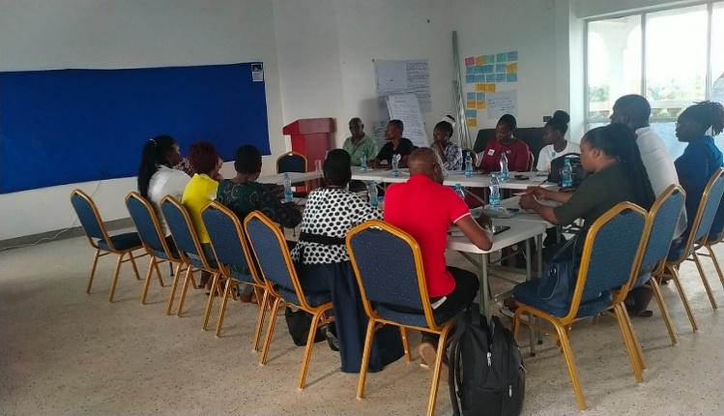**ToP Training by SCR Kenya** SCR Kenya organized a five-day Technology of Participation (ToP) Group Facilitation Methods Training at Celpan Apartments on Mariakani - Kaloleni Road, Kilifi County, from October 8th to 13th, 2023. This course, supported by funding from the Village Volunteer Programme by ICA-UK, aimed to equip participants with essential skills.

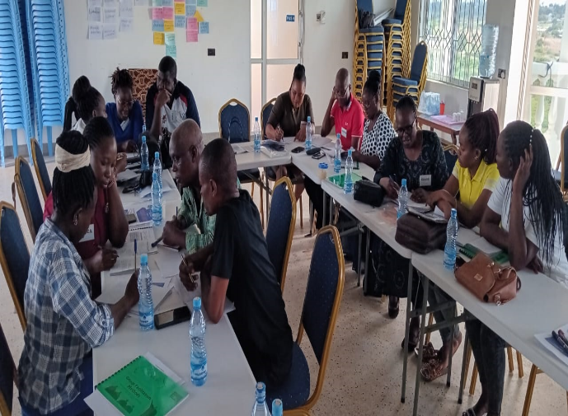Facilitators Patrick Mbullu and Nathan Andika from ICA-Kenya, along with support from Beatrice Imali of SCR, conducted a comprehensive training that included theory, group practices, and reflections on the application of ToP methods. Thirteen participants, primarily linked to SCR—comprising board members, staff, volunteers, and associates—engaged with openness and enthusiasm.

On the final day, John Cornwell joined the facilitation team, showcasing the effectiveness of ToP methods in strategic planning for the network's future.

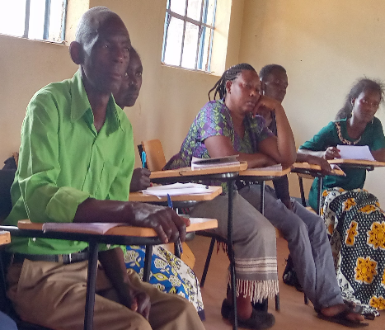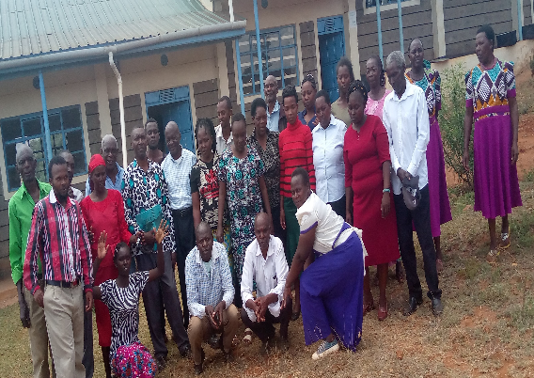**Climate Change Educators Training** From September 18th to 21st, 2023, a four-day training on Climate Change for Community Educators was held at Kyanduya Community Technical Training Institute (KCTTI) in Watema Location, Kee Ward, Kaiti Sub-County, in Makueni County.

**SHG Training and Solar Energy Home Kit Demonstration:** Leaders from eight Self-Help Groups (SHGs) participated in a training session facilitated by the Global Fund ICA-USA. The 22 participants not only embraced the home solar energy kits project but also expressed interest in initiating a water tank project using a similar collaborative approach.

Committing to organizing regular group meetings, participants aimed to share information and identify those without home solar energy kits, fostering mutual support within the community.

 During the SHG training, a practical demonstration of home solar energy kits was conducted, showcasing the potential benefits and practicalities of the project.

Explaining the solar energy home kit parts to ICA Kenya staff

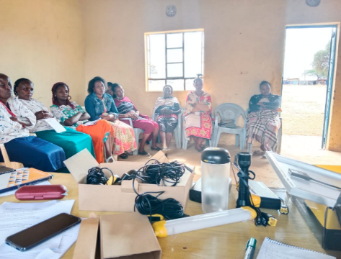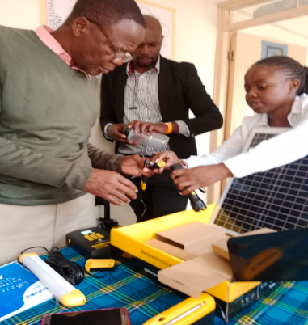D*uring the SHG training and solar energy home kit demonstration*.

Top of Form